Single Channel

A single channel can be a unique communication channel, which is for information only, or a unique commerce channel through which goods, services, and information flow from vendor (or manufacturer, distributor) to consumer (or business customer, dealer, distributor). Such a transactional commerce channel, can be online (web site, electronic catalog) or offline (store, printed material). hybris provides tools like for feeding information into channels and other tools for implementing the channels themselves, for example a web shop, a mobile shop, a print catalog, or an electronic catalog.

Multi Channel

Multi channel is the concept of offering not just one communication or commerce channel to your consumers (or business customers, dealers) but multiple. In order to ensure consistent information like product information, pricing, or promotions in all channels, a single source of truth of product data is mandatory. This is achieved by a Product Information Management System (PIM) that tightly integrates with channel specific applications. **The hybris Commerce Suite with its strong PIM component enables you to centrally manage product data. In addition, you easily can add channels like e-catalogs, Point of Sales (POS) kiosk systems, mobile web shops, or call center applications extending the options of hybris Commerce and hybris Print**.

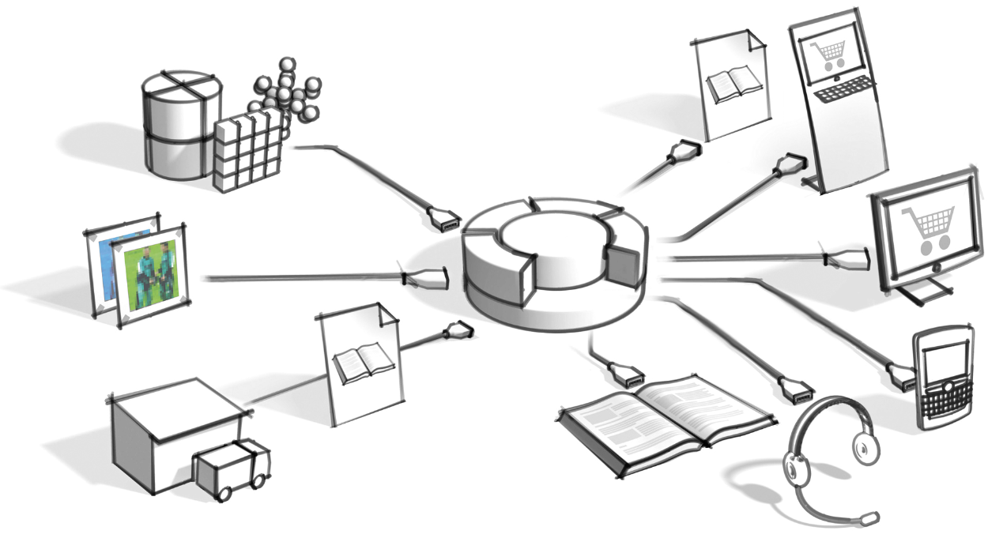  
Figure: Schema of the hybris Commerce Suite. The input channels are on the left, the output channels on the right.

Cross Channel

Based on a consistent multi channel infrastructure, companies can start guiding customers pro-actively from one channel to the other by means of loyalty programs, store events, vouchers, gift cards, special channel specific promotions, and more. If a consistent multi channel infrastructure is not in place this would only confuse customers, due to disparate and often conflicting product information, availability, and pricing information.